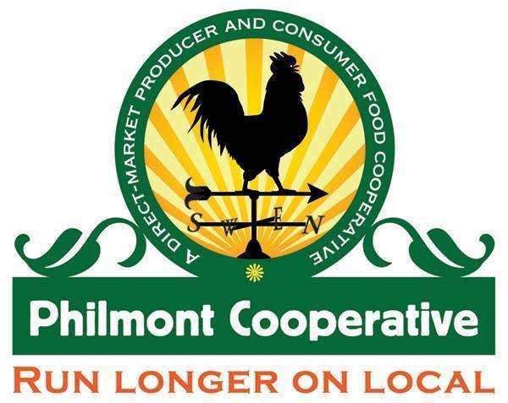

A Producer/Consumer Cooperative

Market address: 116 Main St., Philmont, NY 12565 ● 518-672-7673 philmontcooperative.com
Mailing address: P.O. Box 32 Philmont, NY 12565
info@philmontcooperative.com

Producer Application

Any Producer wishing to sell agricultural products, value-added foods, and non-food items at Philmont Market & Café Cooperative (PMCC) should complete and submit an application and Member-Ownership Agreement..

- All Producers must complete the attached Product List and estimated availability of product.

Philmont Market & Café Cooperative (PMCC) management will review all applications and assign market retail space based on the following criteria:

- The prioritization policy outlined in the PMCC Guidelines (geographic proximity, sustainability, market seniority)
- Giving preference to Producers who plan to participate throughout the year.
- Produce Producers providing the best product mix and consistency of product for shoppers

COMMITMENT ON THE PART OF ANNUAL PRODUCE PRODUCERS
Producers must commit to come at least once per week, preferably on Thursday’s or a specific scheduled time.

Producers must keep the space allocated to them stocked in a reasonable manner. If Producers’ areas are left empty repeatedly, those Producers may lose their spaces. Extra product may be brought in and kept in back-up coolers for PMCC staff to restock.

Producers must inform the Market Manager if they will be absent due to vacations, etc. Producers should also post signs to inform their customers of this.

Producers should plan how best to display and care for their products. Produce prone to wilting should be located in cooled areas, bagged, in water, etc. All products should be labeled before leaving them at the market or arrangements should be made with Market Manager if it is otherwise.

Producers are encouraged to hang signs to identify their areas and “brand” their products.

COMMITMENT ON THE PART OF PHILMONT MARKET & CAFÉ

In exchange for the forethought and commitment made to PMCC by Producers, PMCC agrees to limit the number of Producers selling the same types of items. During times of surplus PMCC encourages Producers to use the value-added processing kitchen.

PMCC encourages Producers to communicate and collaborate so that all may enjoy the largest success possible.

SALES OUTLETS AND RATES

Curbside Café: See Cafe Agreement
Cost to rent Curbside Café Food Truck or Indoor Cafe (Winter Months) is $75.00 per week & % of net sales.

Inside Store: See Market Rules for cost range for retail display and sales.

Value-Added Processing Kitchen: See Market Manager for details about share costs to rent the kitchen for value-added food production, classes, and events.

SPECIALTY PRODUCTS
Producers who do not produce a large enough variety of products to maintain a spot through the year or produce only specialty items (like ginger, blueberries, strawberries, turkeys, etc.) may still participate in selling through PMCC market.

Arrangements for delivery of specialty product(s) should be agreed upon with the Market Manager prior to delivery. Market Manager has the right to charge an increased percentage of sales to that of the Producers who have committed through the greatest part of the year.
A Producer/Consumer Cooperative

Market address: 116 Main St., Philmont, NY 12565 ● Telephone: 518-672-7673 ● philmontcooperative.com
Mailing address: P.O. Box 32 Philmont, NY 12565
info@philmontcooperative.com
Producer Application

Name(s): Member #

Farm/Business Name:

Mailing Address:

City: State: Zip Code: County:

Phone Cell

Email

Website

- I am interested in selling through (Check all that apply)

- Inside Store

- I am interested in selling to (Check all that apply)

- Curbside Café
- Value-added kitchen Producers

Please list products you would like to sell through Philmont Market & Café Cooperative:

Section 1 – Farm Products (Include: produce, meat, dairy, eggs, honey/syrup)
- What is the size of your farm? What is the acreage under production? _
- What best describes your growing practices (Check all that apply):
  - Certified Organic – If Certified Organic, please attach a copy of your certification.
  - Sustainable – Not Certified Organic, but using only Organic Material Review Institute (OMRI)- approved inputs.
  - IPM – Use Integrated Pest Management Practices; may use chemical fertilizer/pesticides/herbicides
  - Livestock: ______________________________________________

Grain- Fed ______ Pastured or Grass-Fed _____

If raising chickens for eggs and/or meat:

Number of chickens:________

Cage Free/Free Running______ Free Range ______ Pastured ______

- I have received the following Good Agricultural Practice (GAP) or other safety training. Please list:

Section 2 – Value-Added Food (Includes: dairy, honey/syrup, bakery/candy, jams/jellies, granola, salsas)

- Where/how is your product processed?

- Processed at a home kitchen: | Name & Address:
- Processed at a 20-C processing kitchen: | Name & Address:
- Processed at a licensed commercial facility: | Name & Address:

- Where does the majority of the main ingredients in your products originate?

  - My farm
  - NY Farms
  - Other: ______________________________

Section 3 – Nonfood (Includes: soaps, arts/crafts, nursery & bedding plants)
- Where does the majority of the main ingredients in your products originate?
  - My farm
  - NY Farms
  - Other: ______________________________

Section 4 – Tell Us About Yourself
Please take a moment to write a paragraph about your farm or business, your philosophy, and your production practices that can be shared with customers. Attach additional sheets if necessary.
Begin Writing Bio Here:

Section 5 – Co-op Space Requirements

Check all that apply. (See Market Rules, Cafe Agreement & Kitchen Guidelines)

Market Display Space: Cooler_____Freezer_____Retail Shelves ______Bakery Shelf ____

- Use of Curbside Café

April - October : Outdoor Food Truck

November - March: Indoor Cafe

Days of Week: Mon Tues Wed Thurs Fri Sat Sun

Hours: ___________________________

- Use of Value-added Processing Kitchen

Days of Week: Mon Tues Wed Thurs Fri Sat Sun

Hours: ____________________________

Section 6 – Value Added Production Assistance

- Do you need help with designing a NY State Ag & Markets outlined label
- Do you need help with sourcing local ingredients
- Do you need help with Standard Process for shelf stable products
- Do you need help with creating a Nutritional Information label

I have read and understand the PMCC Producer Guidelines. I agree to comply with all PMCC market rules, regulations, and requirements. I affirm that all information in this application is complete and
accurate. I recognize that the goal of PMCC is to help me sell my products, and I understand that being a part of a cooperative requires flexibility and cooperation from everyone involved.

Signed: ____________________________________

Date: ______________________________________

